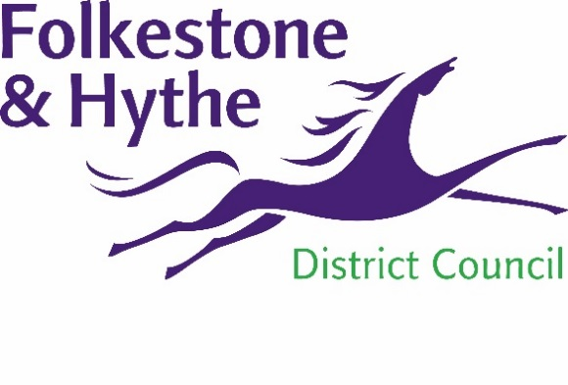
NEWS RELEASE

20 April 2021

NEW PANEL MEMBERS WANTED FOR FOLKESTONE & HYTHE PLACE PANEL

Folkestone & Hythe District Council is inviting applications for membership of a Place Panel, which is being formed to support high standards in new developments within the district.

In 2018 Folkestone & Hythe District Council set up a Place Panel to advise and support the Otterpool Park Garden Town Project. The council now wishes to widen the scope of the panel to reflect a broader range of development and regeneration projects coming forward across the district and to secure high quality design. The panel will have around 20 members with a wide range of skills and expertise, and applications are welcome from experts in the following areas:

- sustainability and low carbon developments
- architecture - housing / cultural / commercial
- town planning / urban design
- landscape / public realm
- heritage / townscape
- inclusive design

Folkestone & Hythe District Council is a dynamic and innovative place to live, work and visit. The district aims to create a world class quality environment that will stand the test of time, whether relating to new homes or ambitious projects that are in the pipeline such as the regeneration plans for Folkestone town centre, its harbour and seafront.

The panel will play an important role, furthering the council’s commitment to securing innovative, sustainable and high quality placemaking that meets the needs and considers the future demands of communities. The panel will provide external rigor and input, to ensure exemplary development in all areas of the district, enhancing Folkestone & Hythe for all those who live, work, and visit.

A spokesperson for Folkestone & Hythe District Council said, “We recognise that good design will help to achieve growth across the district. We shall be looking particularly at how new development – homes and employment opportunities, transport and open spaces – can contribute to quality of life in Folkestone & Hythe for our residents and visitors alike.”

Joanne Cave, chair of the Place Panel said, “I am delighted to chair the Folkestone & Hythe Place Panel and look forward to working with a team of outstanding professional experts who will be appointed as panel members.

“The panel will help to ensure new development strengthens and enhances Folkestone & Hythe’s existing sense of place. The area has immense potential to deliver exemplar placemaking and it is an honour to be tasked with ensuring its special qualities are maintained as new developments come forward across the district.”

Applications should be addressed to Frame Projects, which manages the Place Panel to maintain the independence of its advice. Those who wish to apply should contact folkestoneandhythe@frame-projects.co.uk to request a recruitment pack.

The closing date for applications is Tuesday 11 May 2021.

Notes to Editors:
For more information, please email communications@folkestone-hythe.gov.uk

Follow us on Facebook: @FolkestoneandHytheDC
Follow us on Twitter: @fstonehythedc
Follow us on Instagram: @folkestonehythedc
Follow us on LinkedIn: Folkestone & Hythe District Council

